Lab 3 – Android Studio: To-Do List App Development  
Andrei Koshelev  
100894383  
  
3101-02  
INFT  
  
Durham College  
Mohammad Shamas  
  
  
Friday, October 4th, 2024

**Table of Contents:**Cover Page …………………………………………….............................................. p. 1

Table of Contents ........................................................................................................ p. 2

Screenshots of App Code for First Screen (MainActivity.java)………………... pp. 3 – 4

Screenshots of App Code for First Screen (activity_main.xml)………………... pp. 4 – 5

Screenshots of App Code for Second Screen (SecondScreen.java)……………. pp. 5 – 9

Screenshots of App Code for Second Screen (second_screen.xml)…………... pp. 9 – 11

Screenshots of App Code for Second Screen (strings.xml)…………………............ p. 11

Screenshot of the app output in the Android Studio emulator (activity_main.xml)…………………......................................................................... p. 11

Screenshots of the app output in the external emulator (BlueStacks)   
(activity_main.xml)……………………………………………………........... pp. 12 – 13

Screenshot of the app output in the Android Studio emulator (second_screen.xml)…………………....................................................................... p. 13

Screenshots of the app output in the external emulator (BlueStacks)   
(second_screen.xml)……………………………………………………................... p. 14

Reflection ................................................................................................................... p. 14

**Screenshots of App Code for First Screen (MainActivity.java):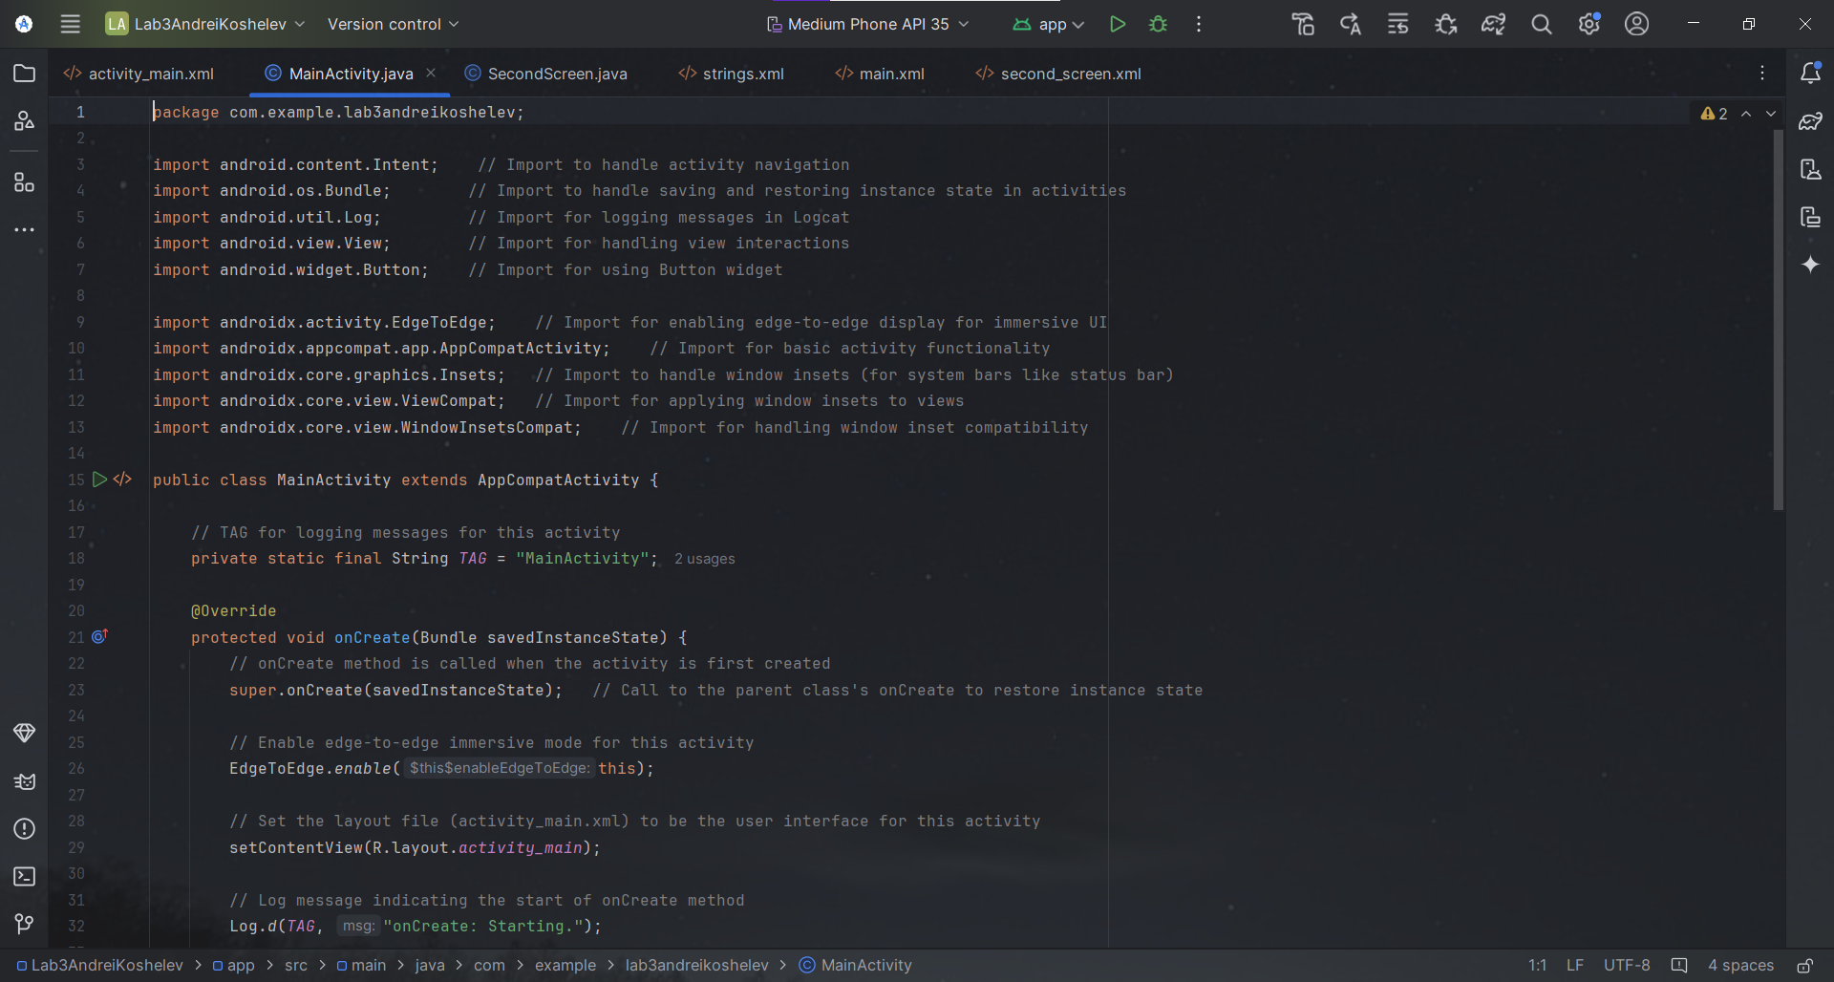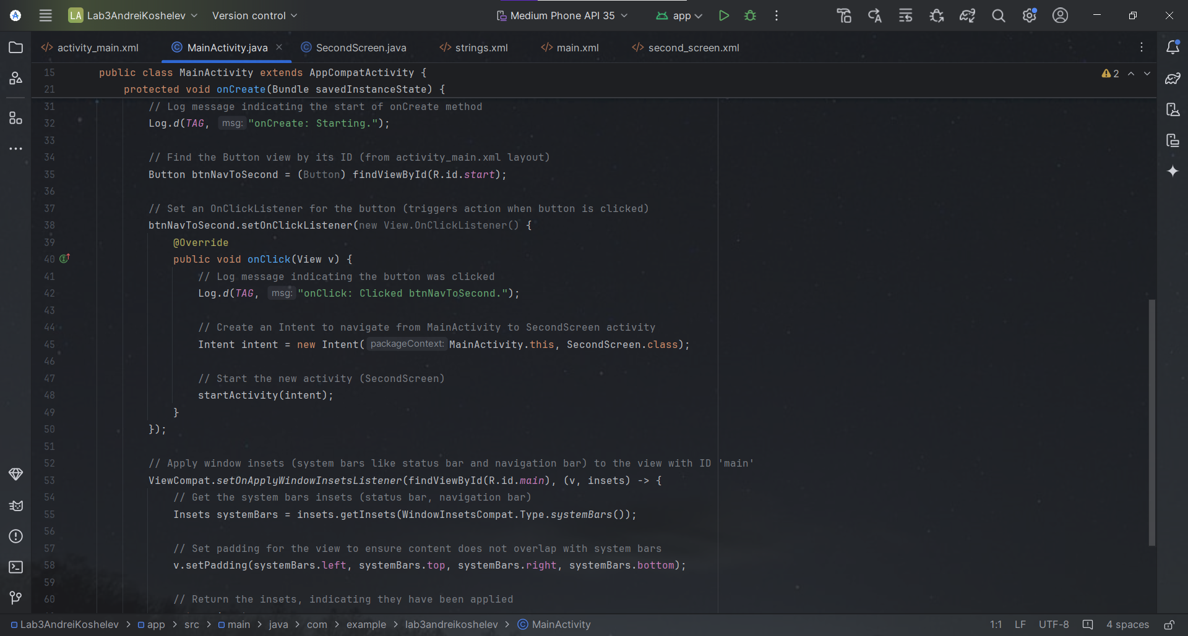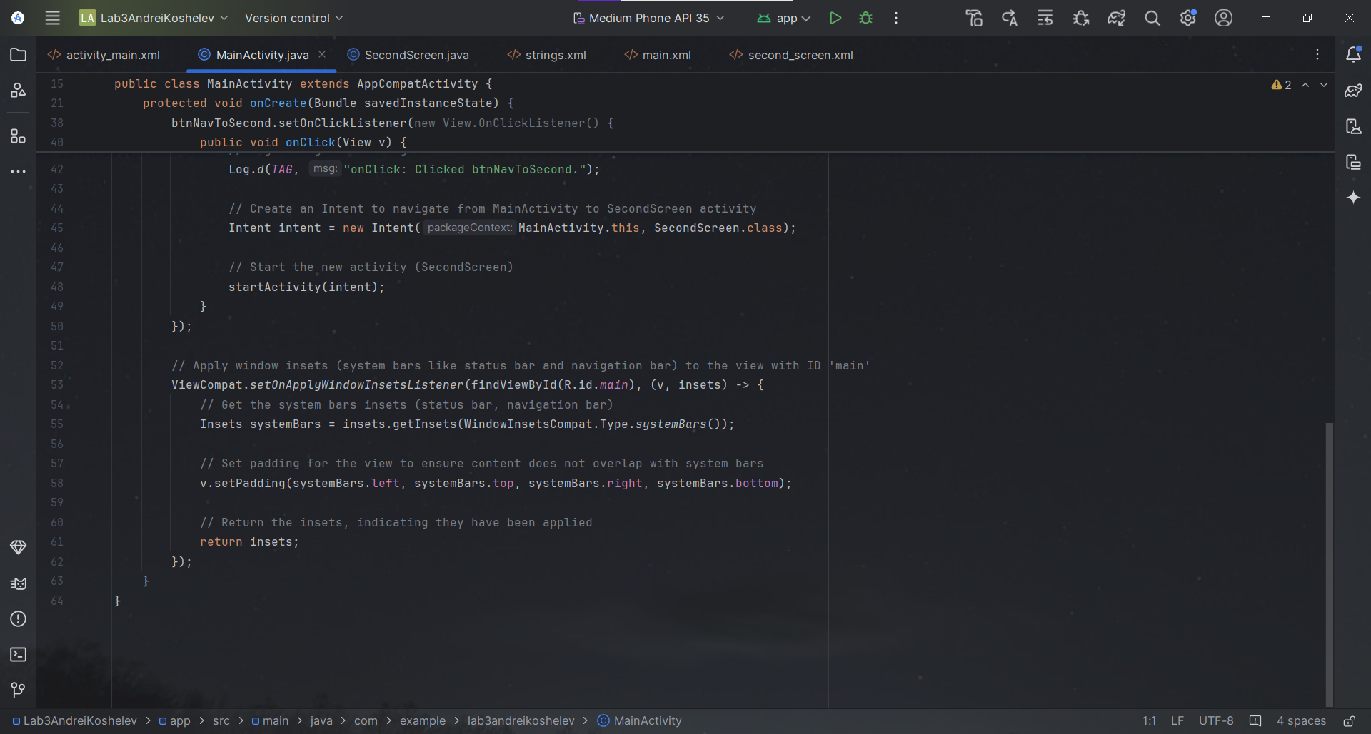 Screenshots of App Code for First Screen (activity_main.xml):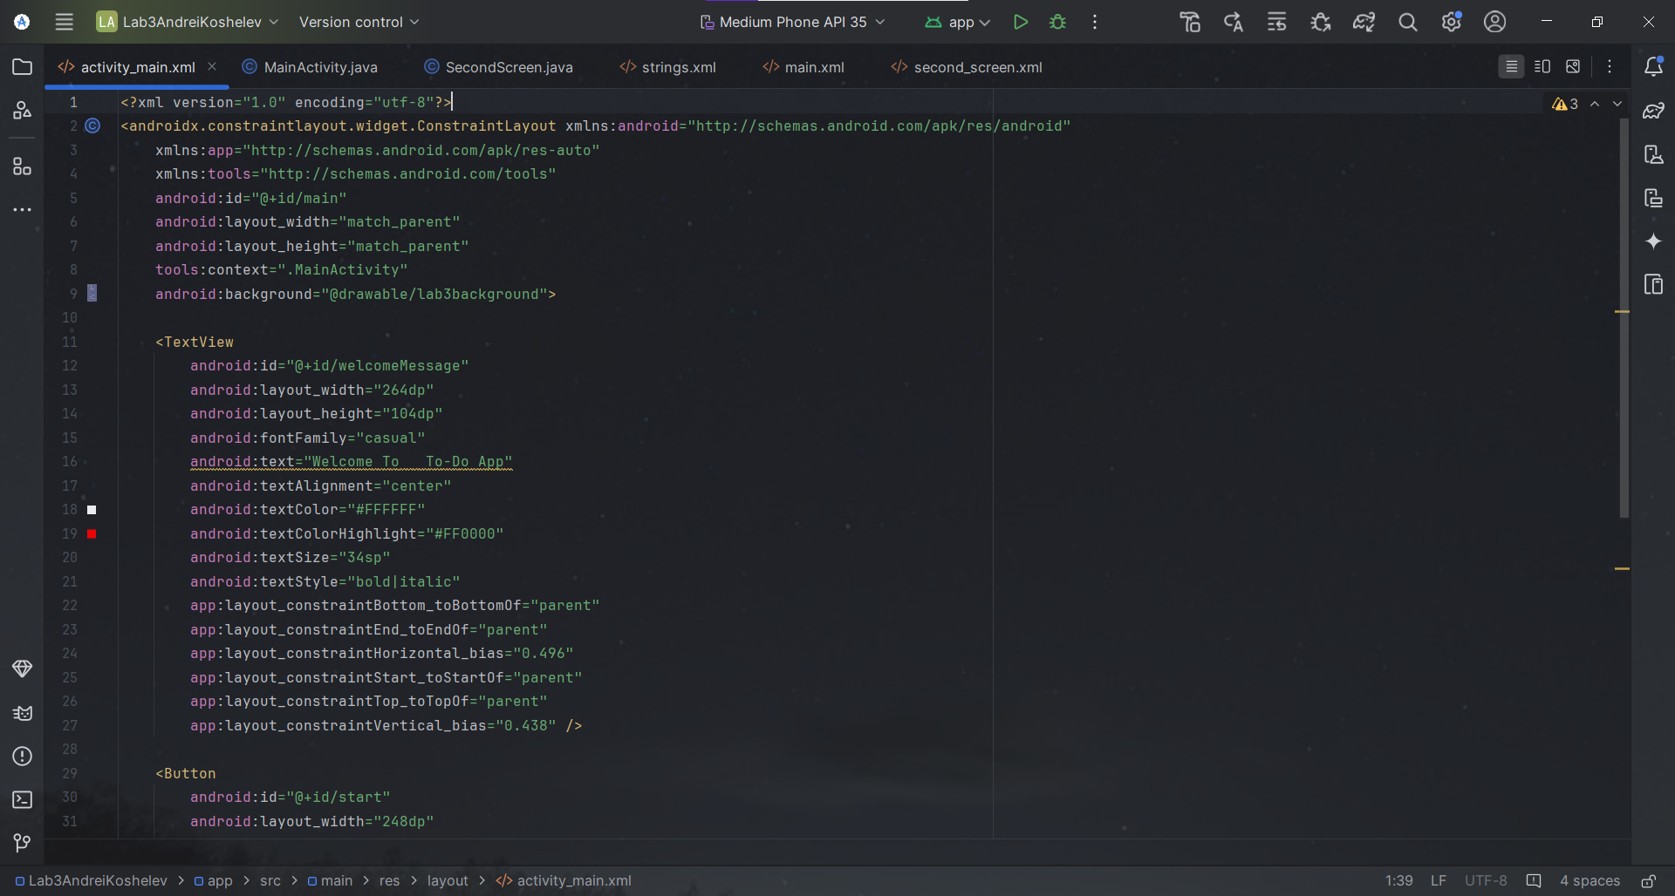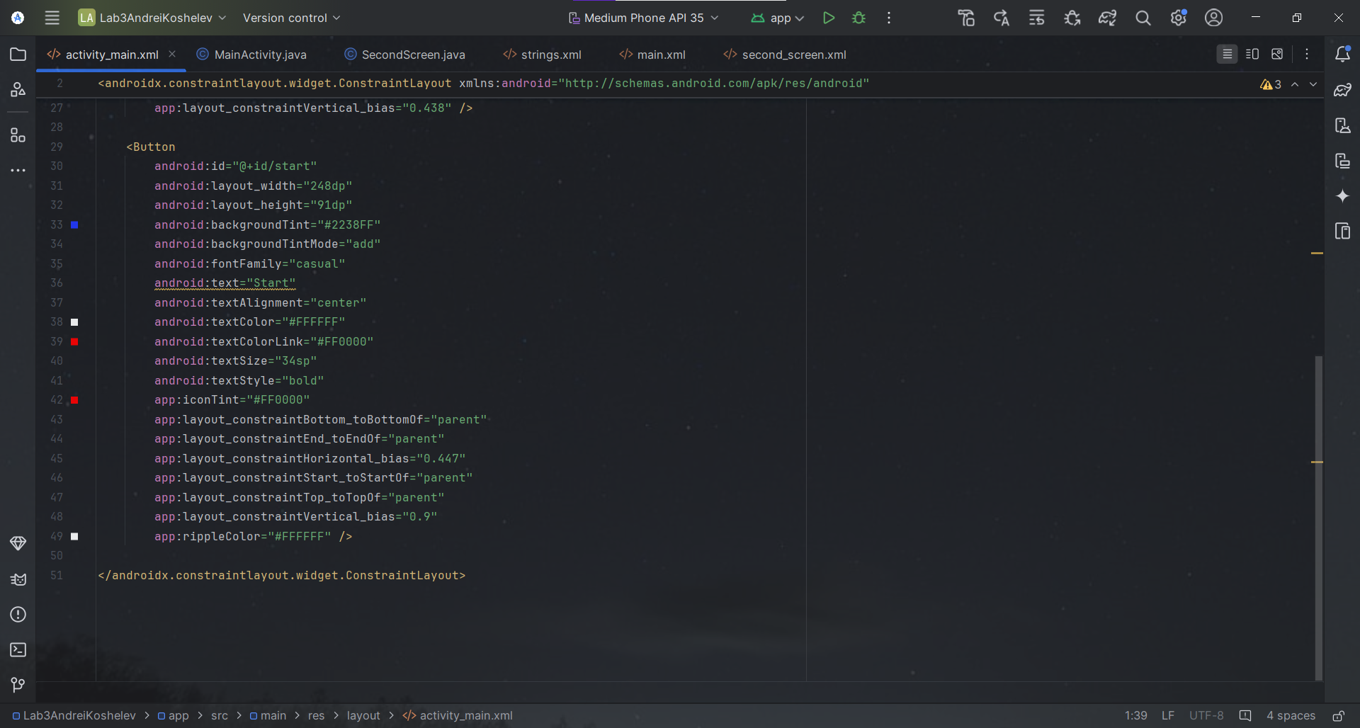 Screenshots of App Code for Second Screen (SecondScreen.java):  
  
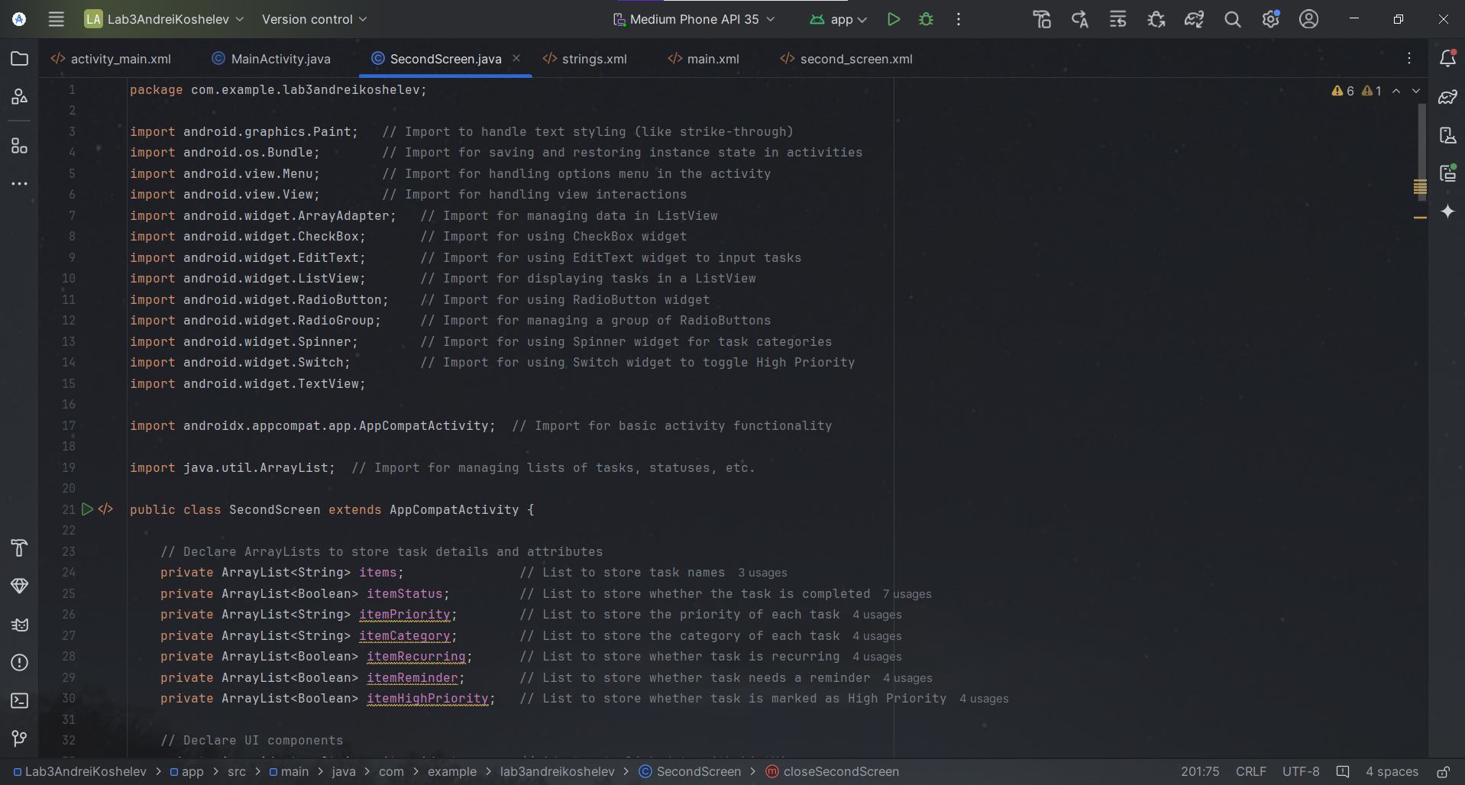  
  
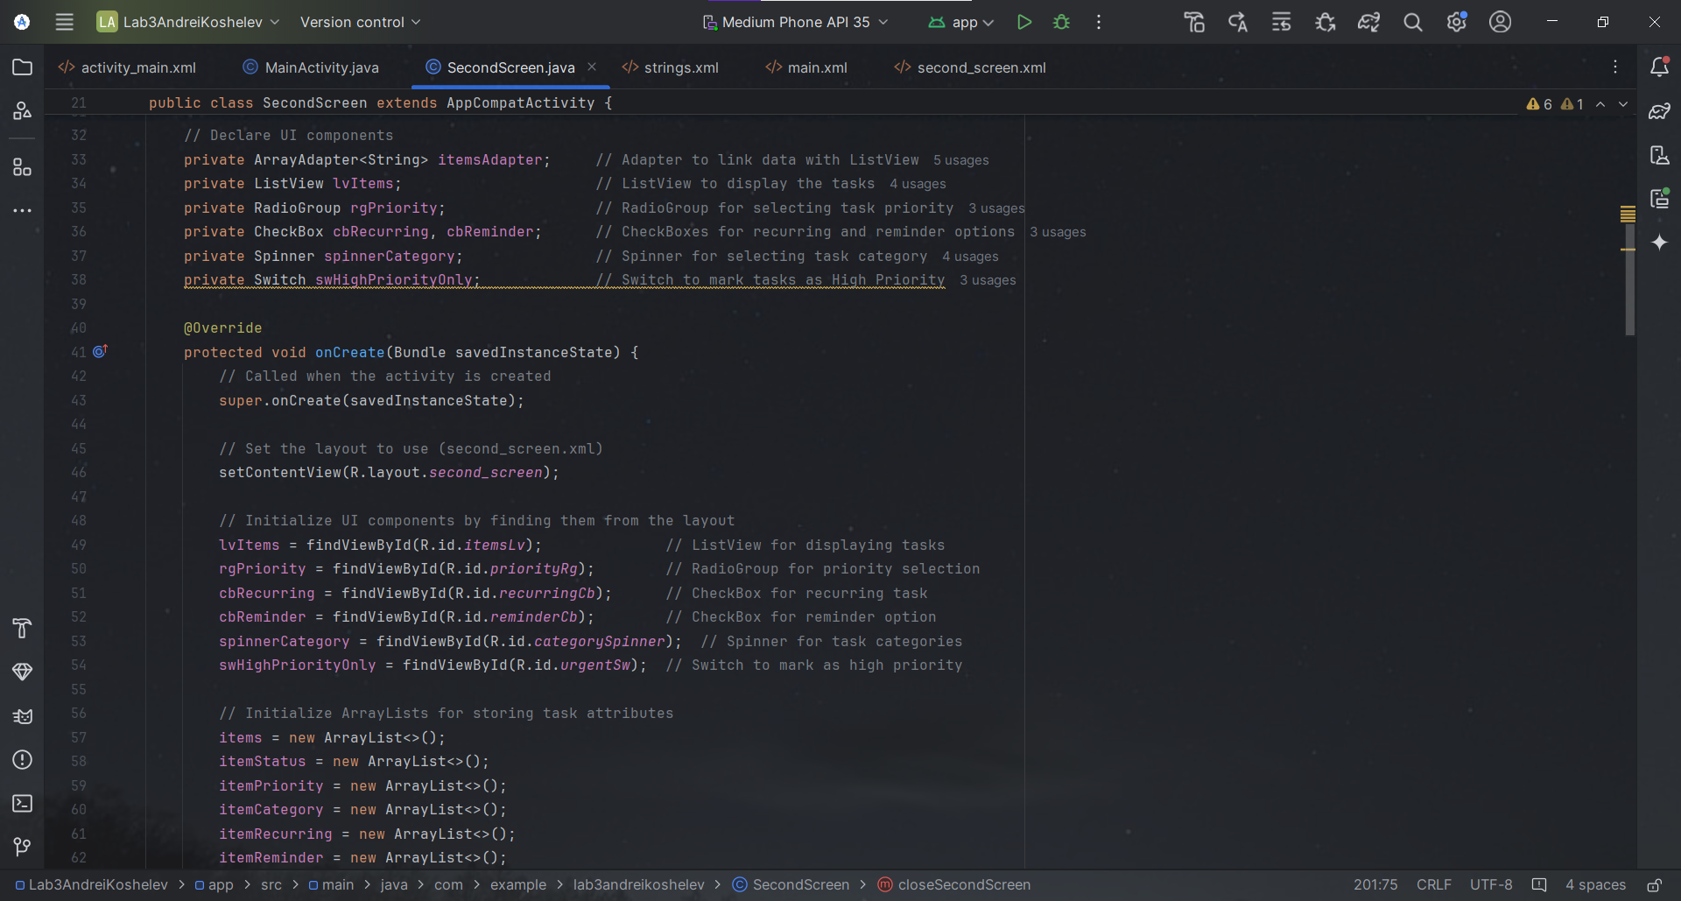  
  
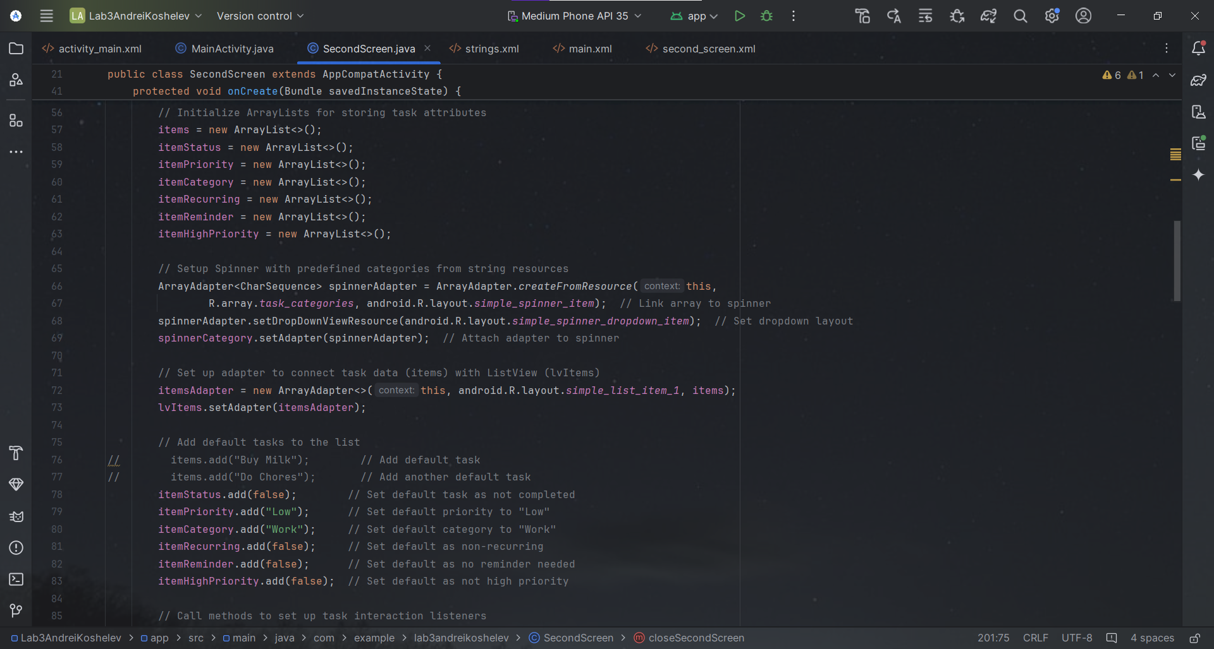  
  
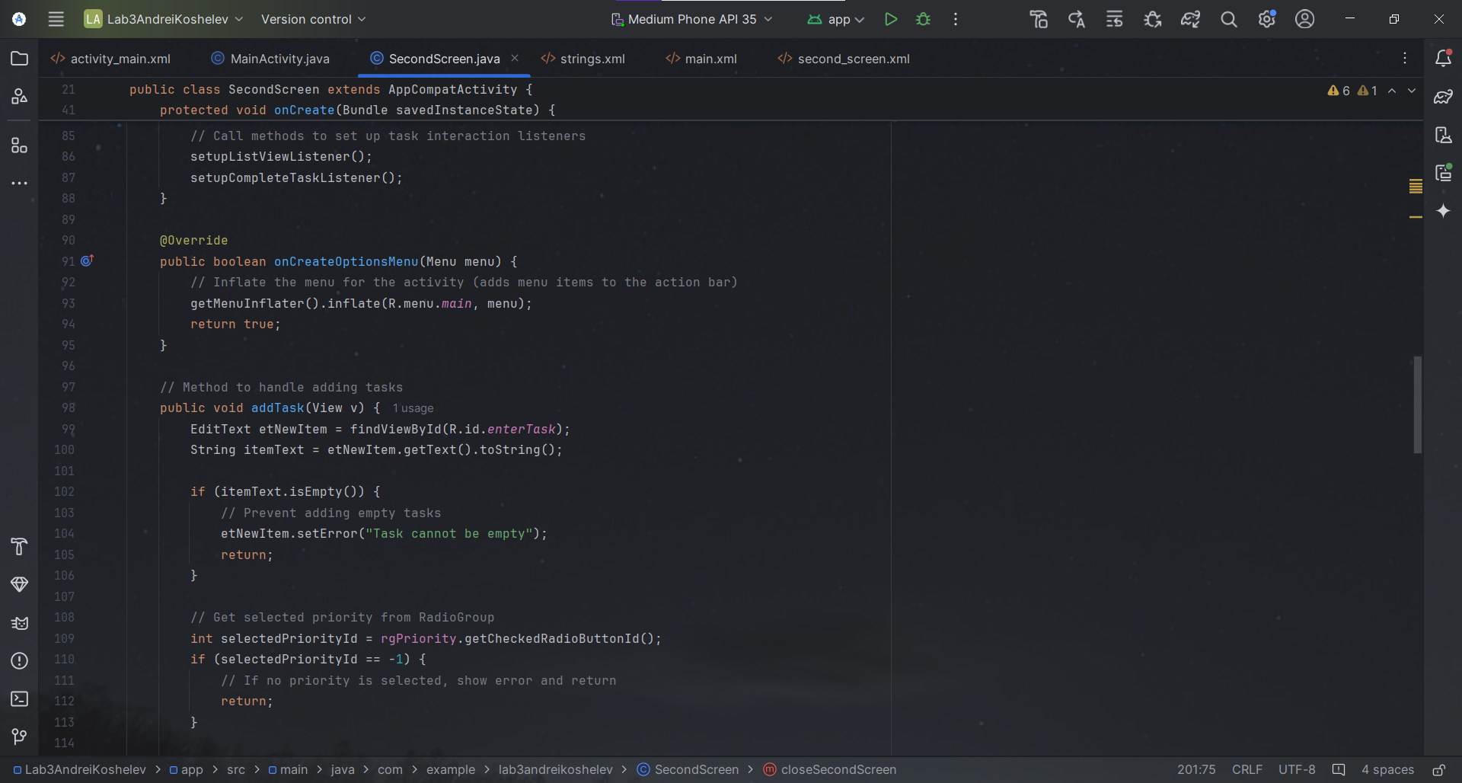  
  
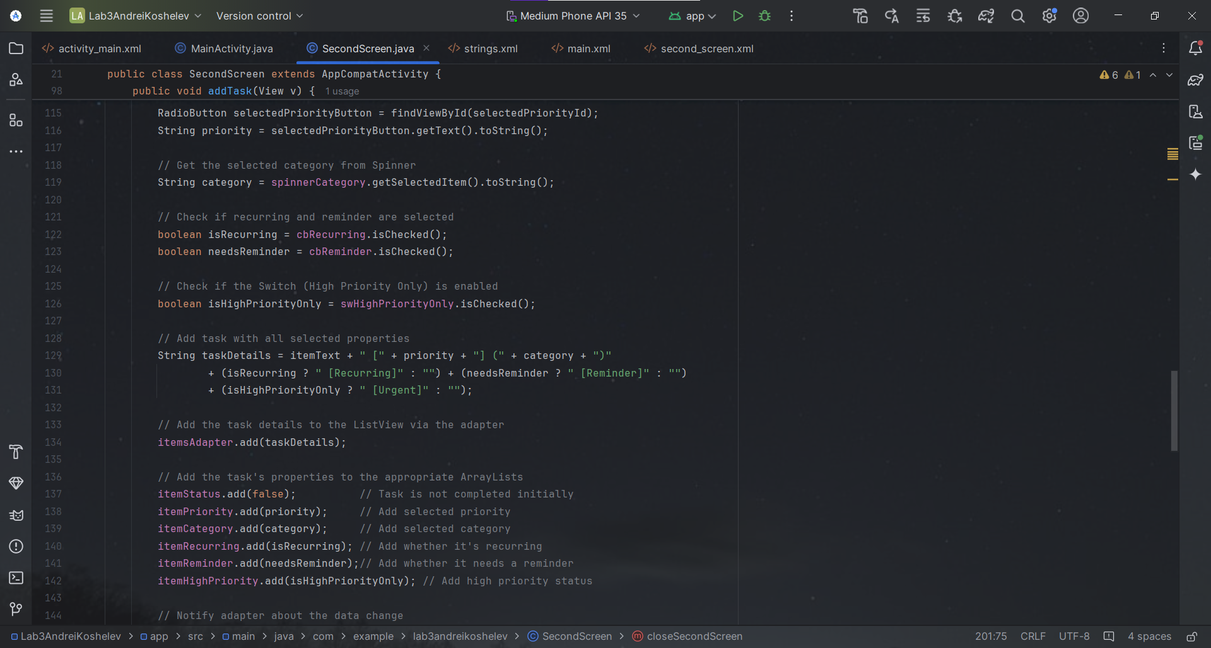  
  
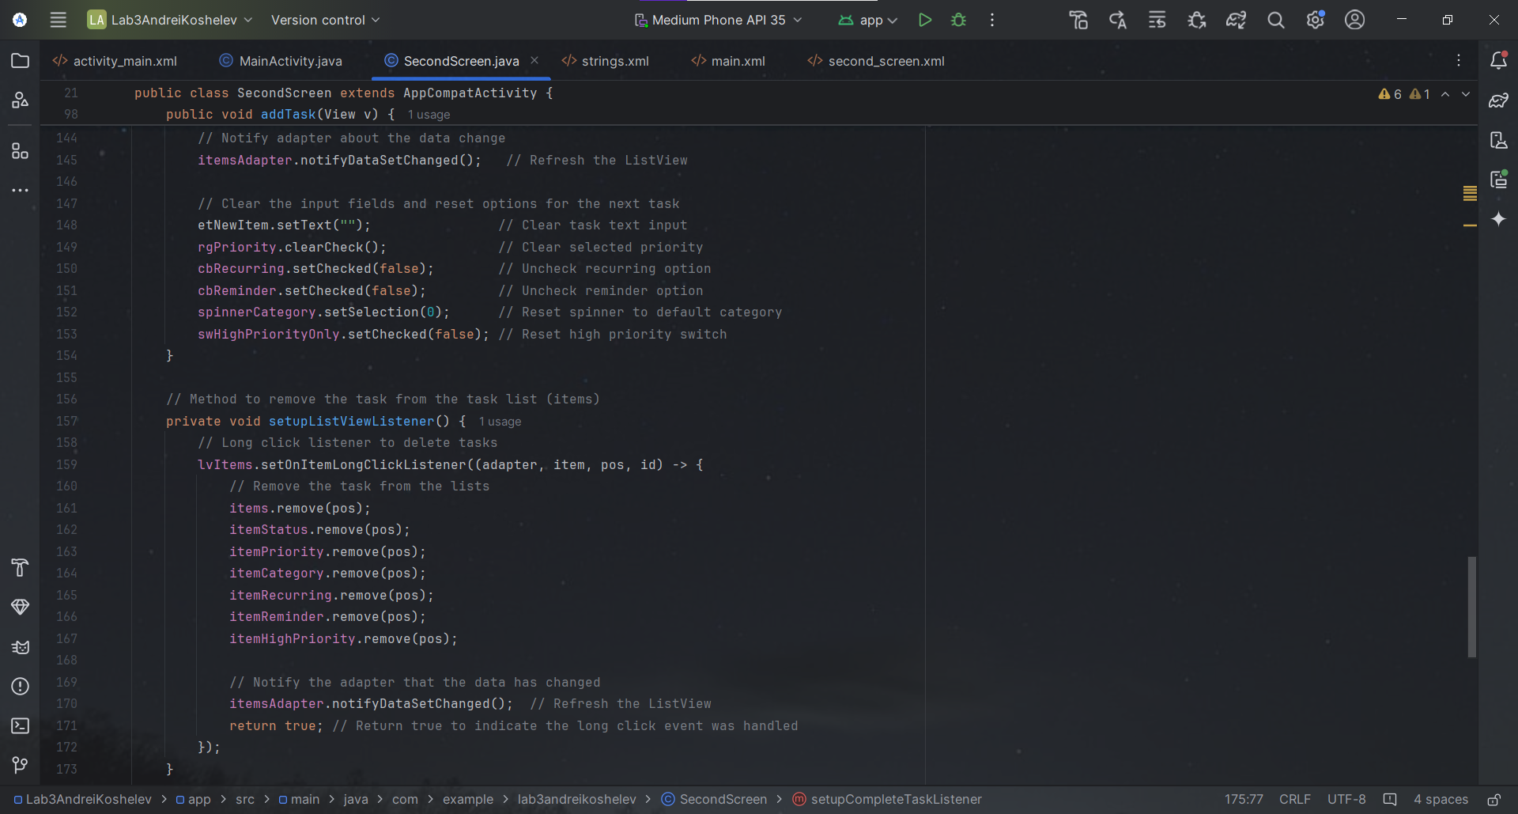  
  
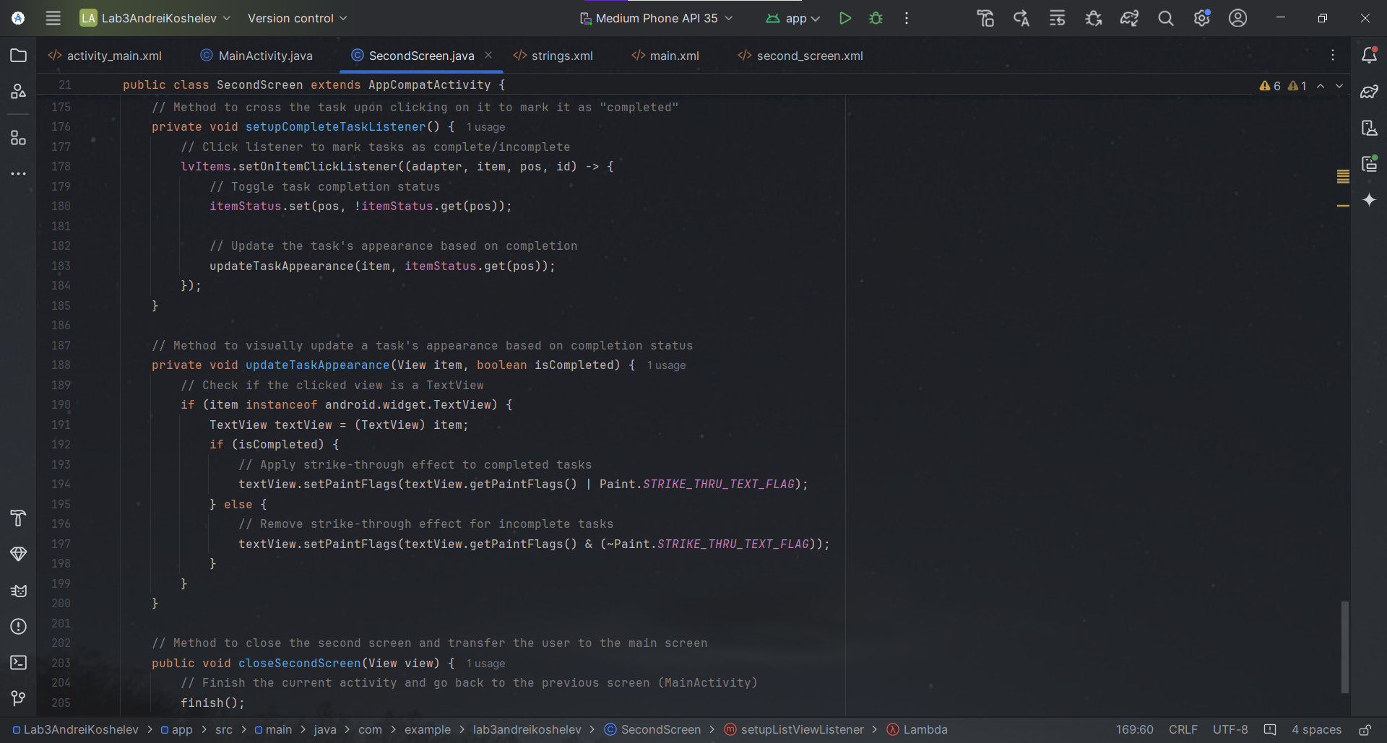  
  
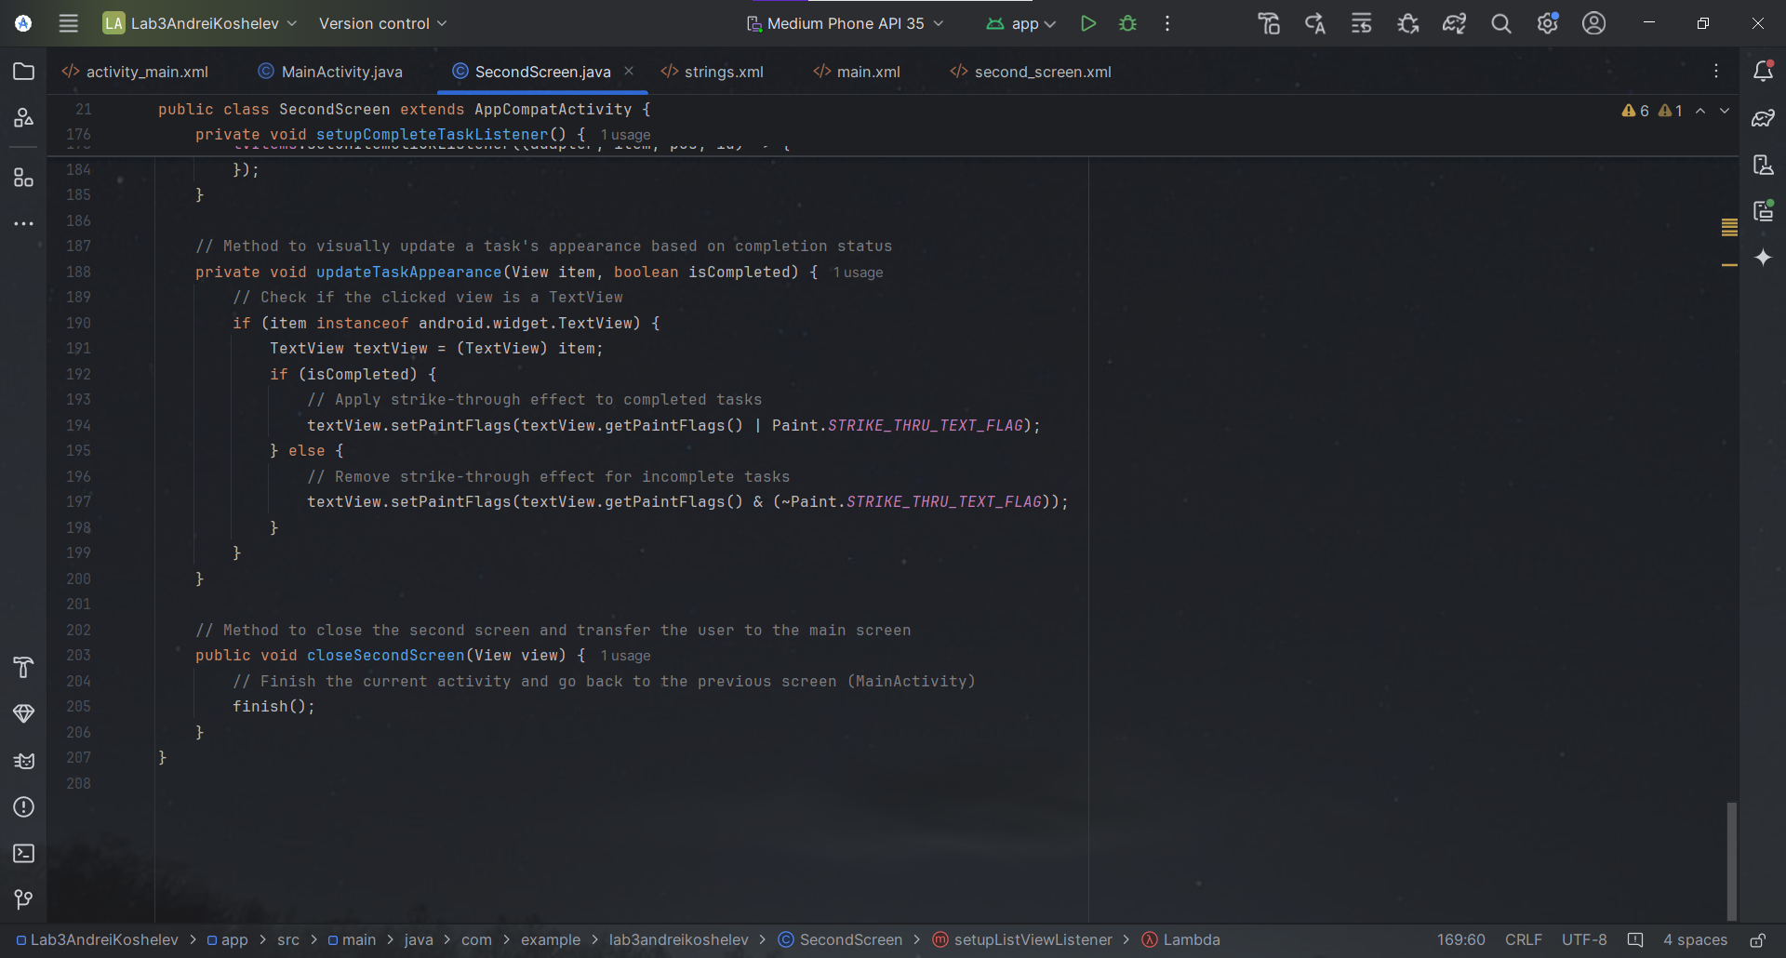  
  
Screenshots of App Code for Second Screen (second_screen.xml):  
  
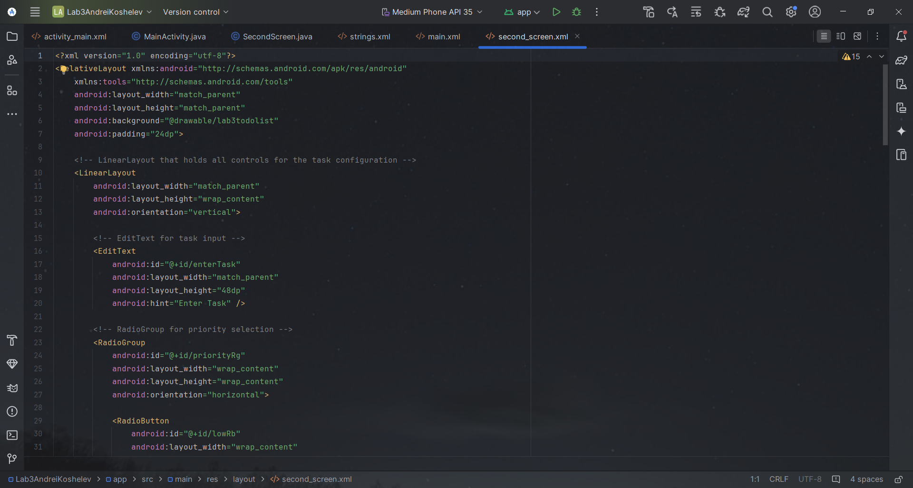  
  
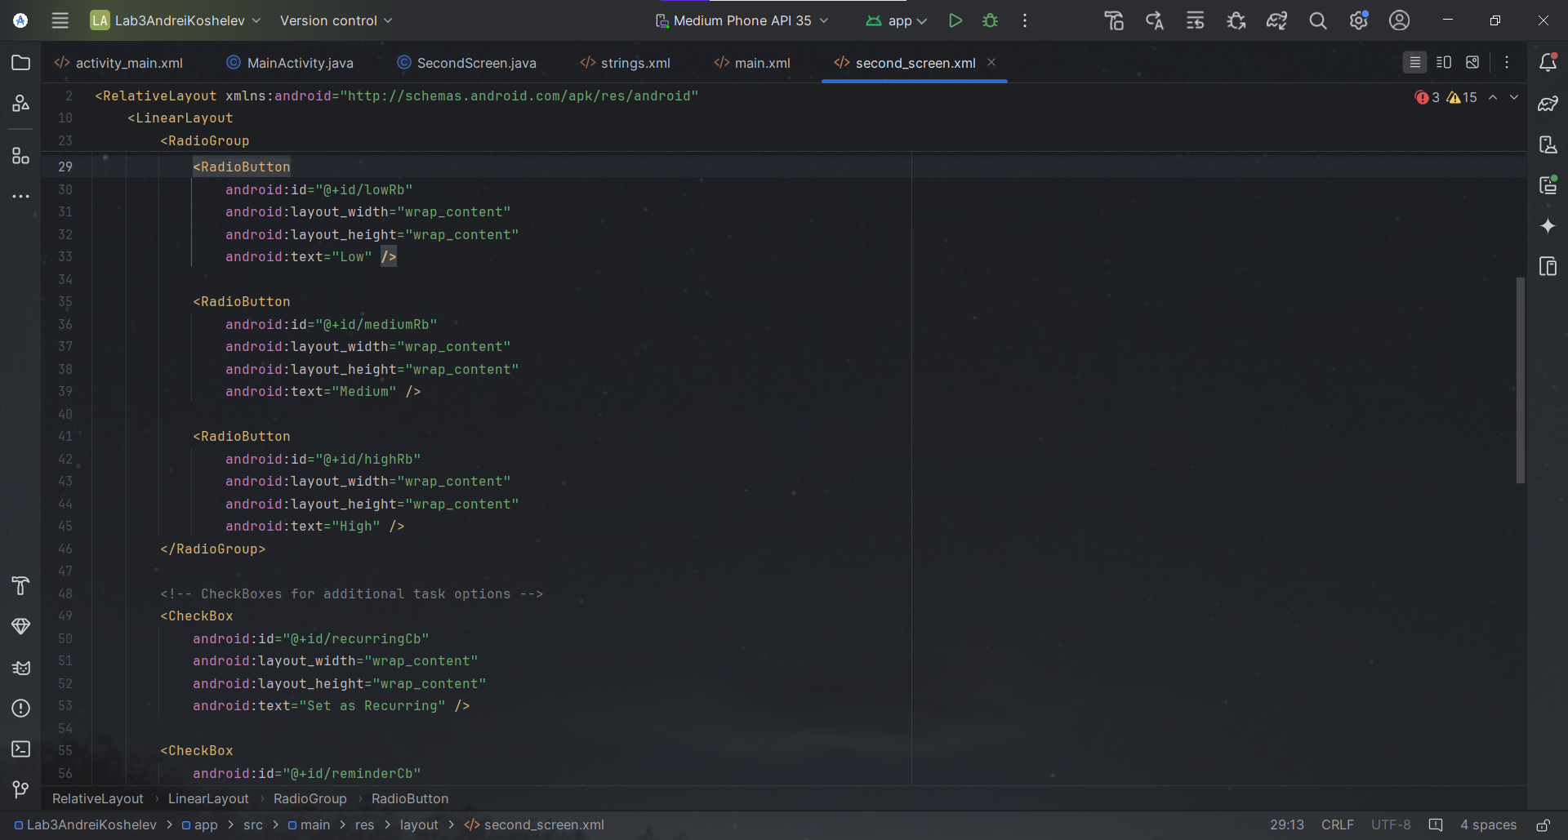  
  
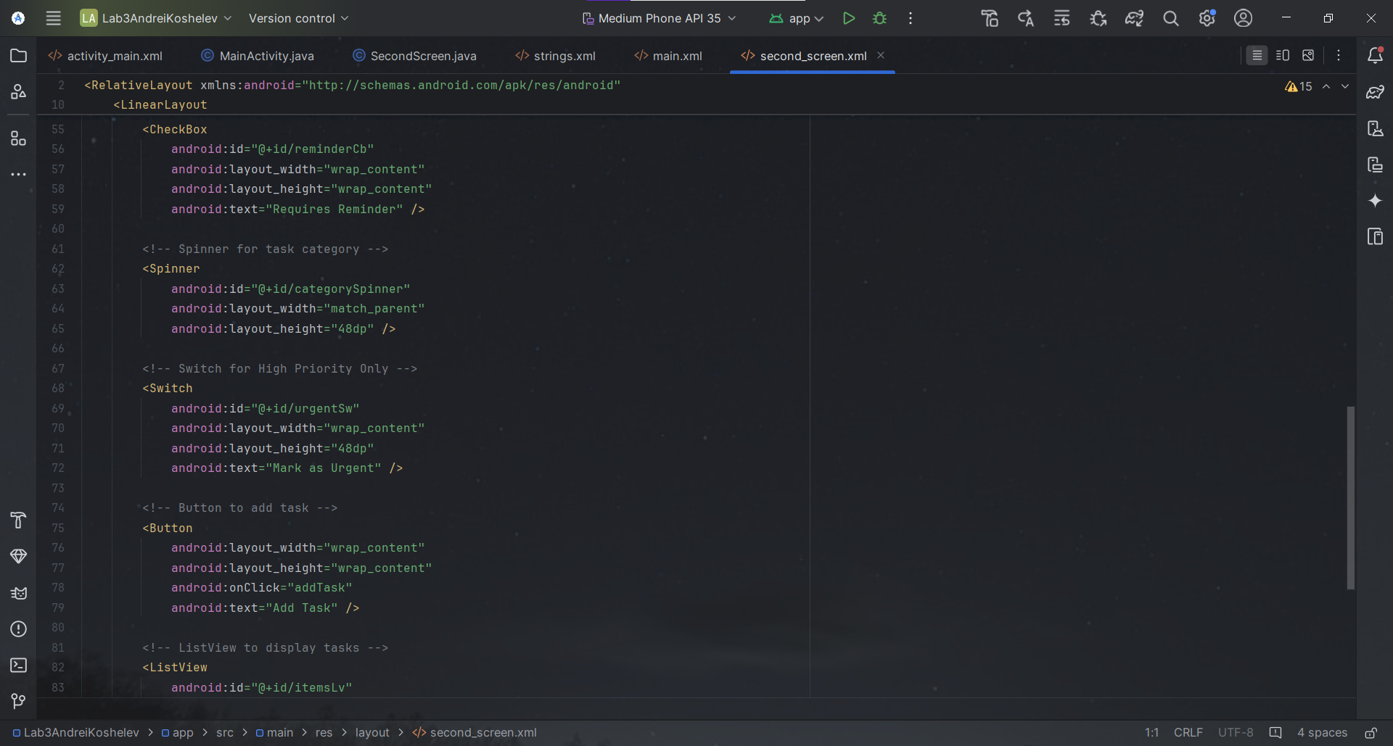  
  
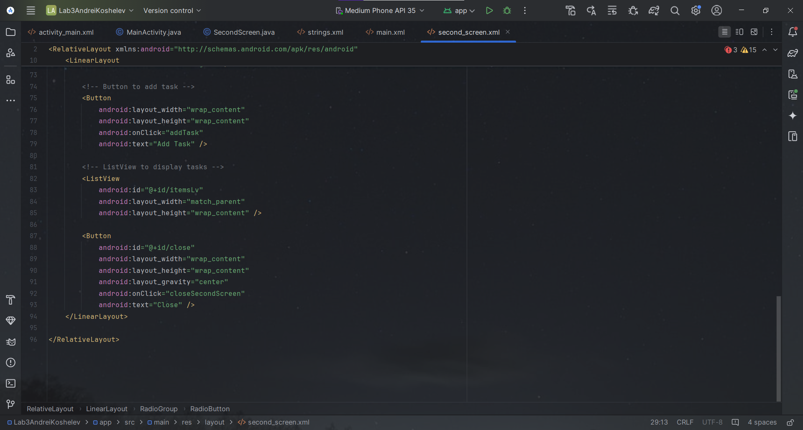  
  
Screenshots of App Code for Second Screen (strings.xml):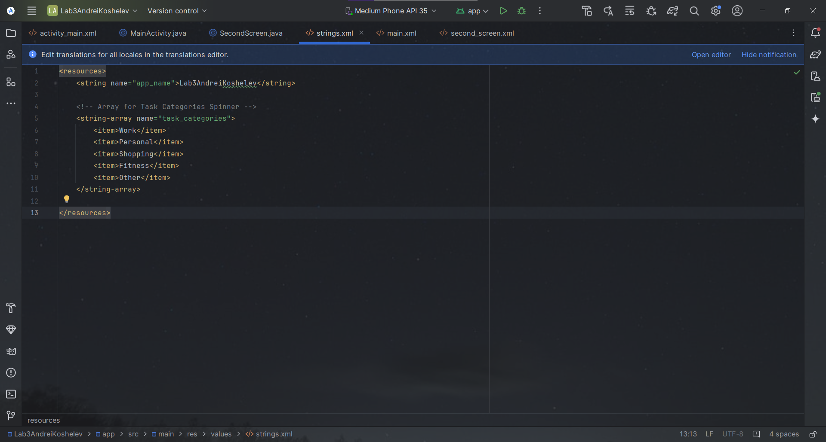 Screenshot of the app output in the Android Studio emulator (activity_main.xml):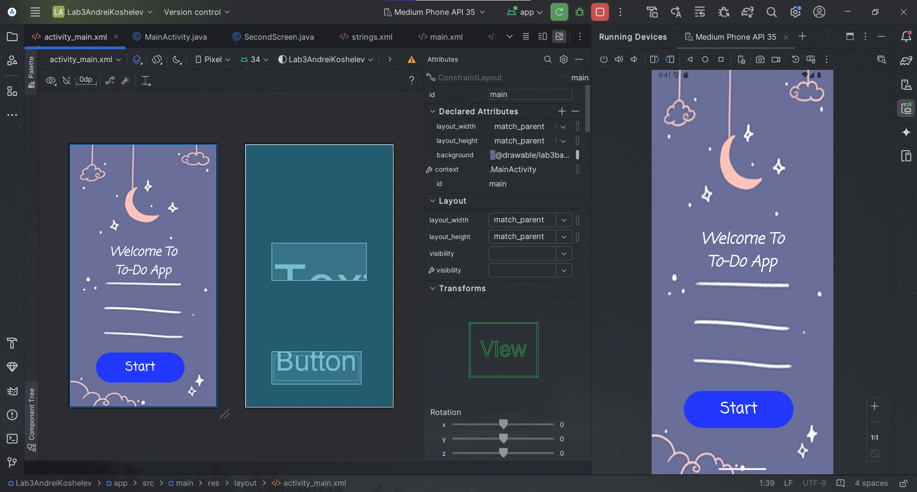 Screenshots of the app output in the external emulator (BlueStacks) (activity_main.xml):  
  
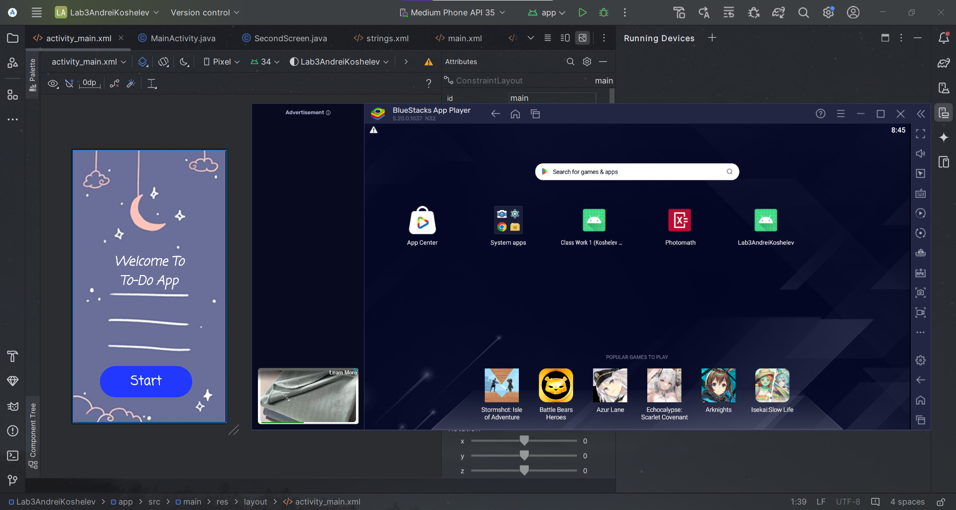  
  
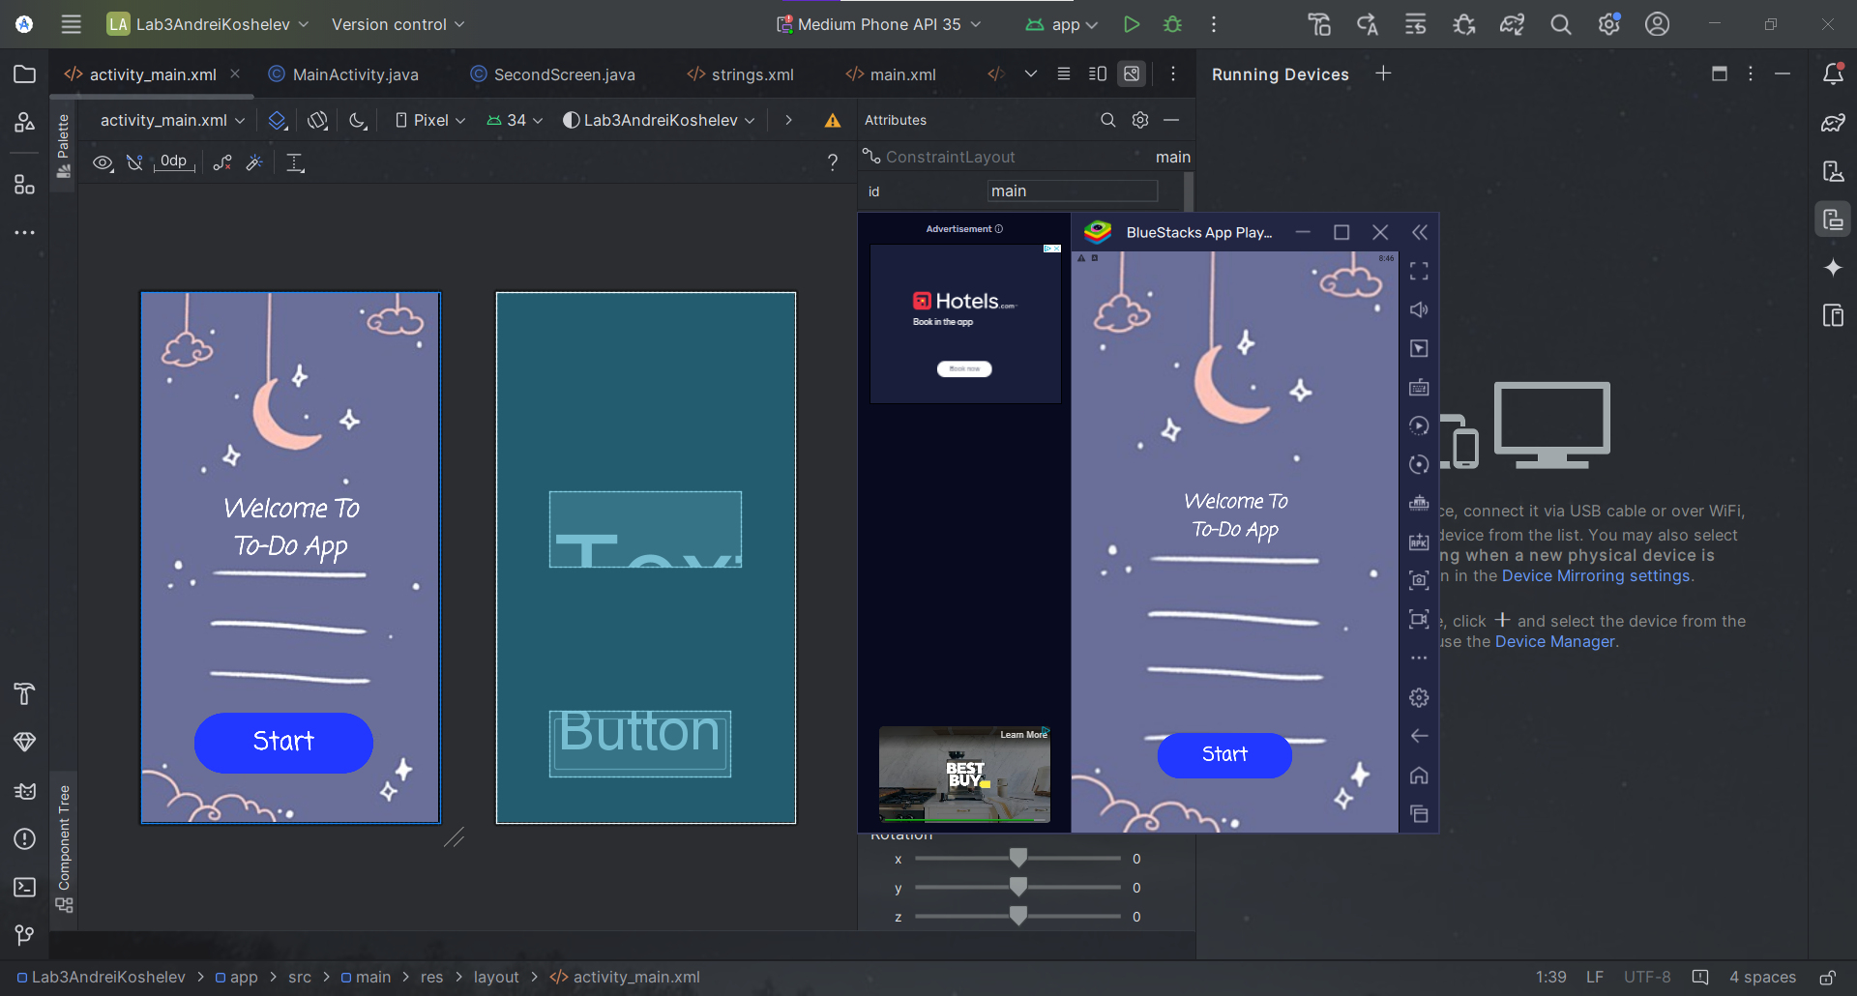  
  
Screenshot of the app output in the Android Studio emulator (second_screen.xml):  
  
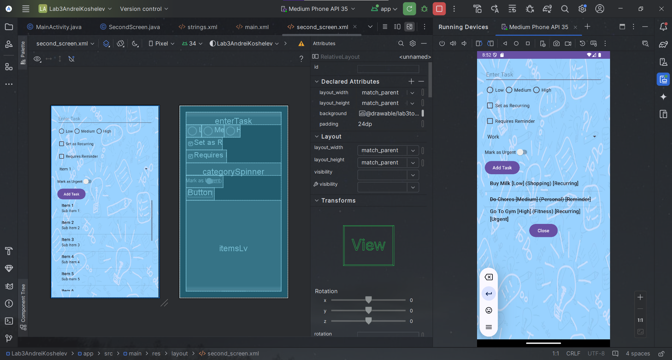  
  
  
  
  
  
Screenshots of the app output in the external emulator (BlueStacks) (second_screen.xml):  
  
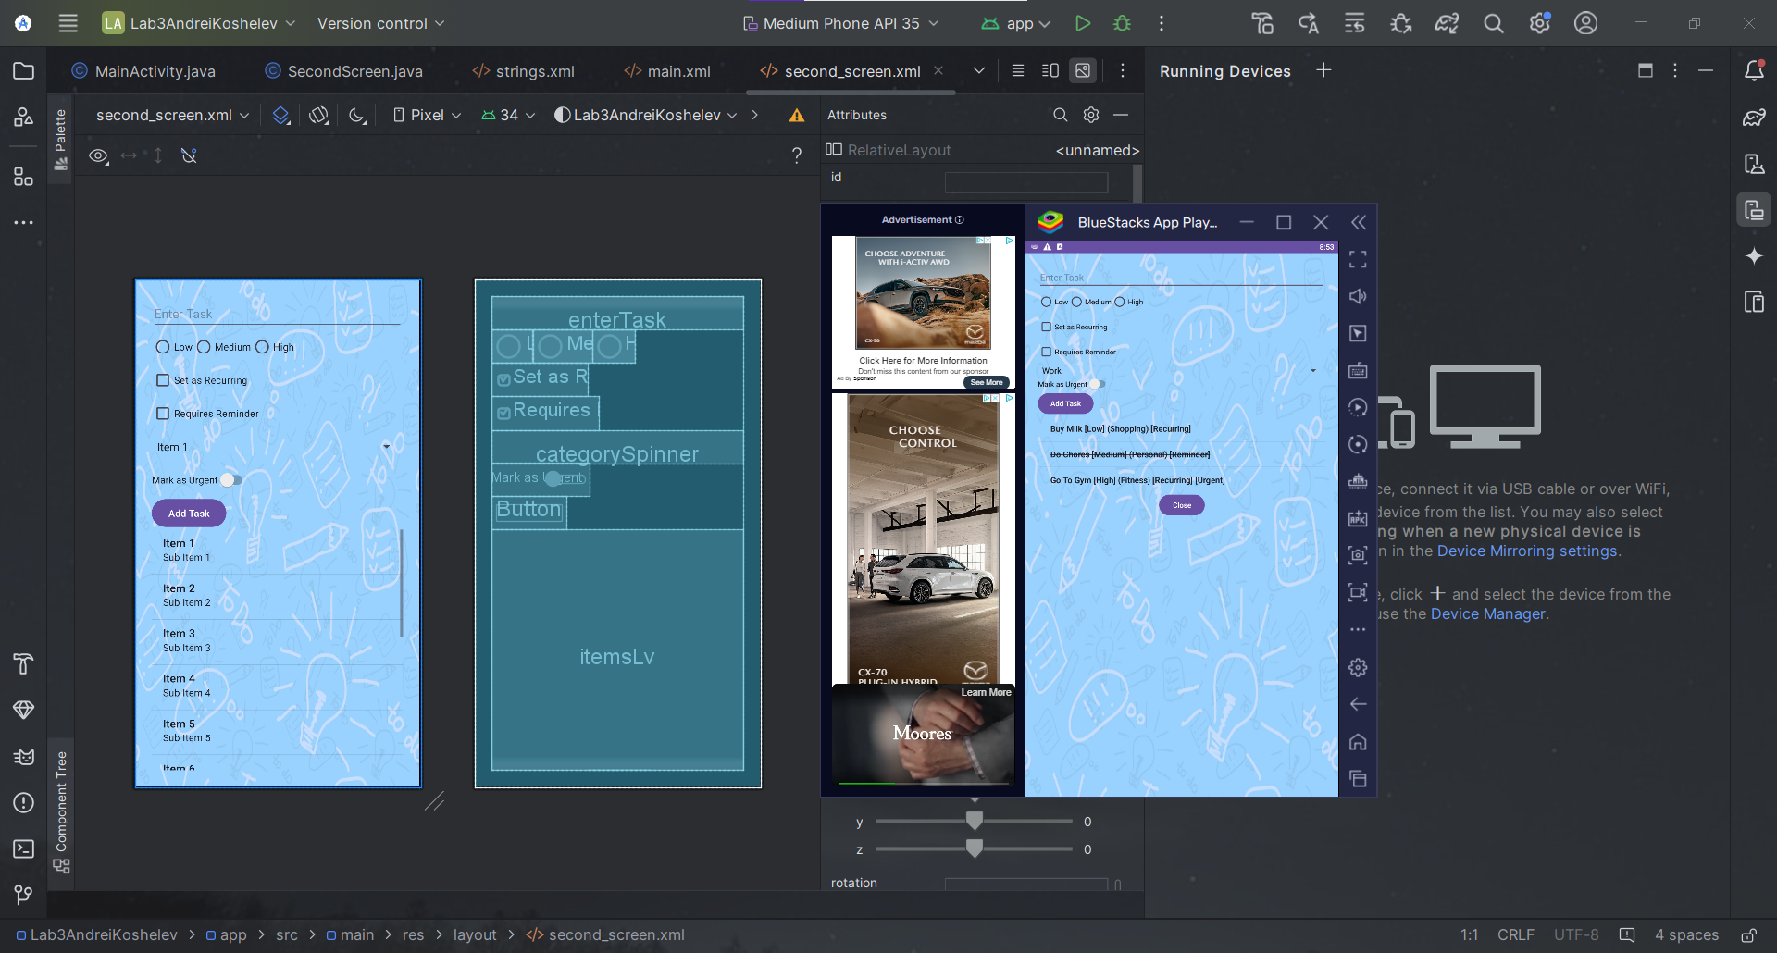  
  
  
Reflection:**

During this lab, the main difficulties I encountered were various function failures and application crashes due to these function failures. Initially, I decided to make a math quiz, but during the long development of this quiz, I encountered a huge number of errors that took several hours or even days to resolve. In the end, I decided to completely redesign my application and decided to make a to-do list.

While working on it, I noticed significant progress in fulfilling the requirements for this lab and thus I managed to achieve the desired result as a fully functioning application, where I can add tasks/mark them as completed/delete them, as well as configure each added task.

My overall experience with Android Studio is quite positive, every day I become more comfortable working on this application and I really like using it.

I started working with external emulators quite a long time ago and it itself did not cause any difficulties. It is very easy to navigate and I had no problems using it for this lab.